Project Design Document | 06/29/2026  Gilbert Anderson

Project Concept
1  Player Control |  | You control a  vehicle | in this  top Down game
 |  | where  keyboard and arrow keys | makes the player  Move left and right

2  Basic  Gameplay |  | During the game,  rocks appear | from  the top of the screen
and the goal of the game is to
avoid the rocks.

3  Sound  & Effects |  | There will be sound effects  a simple impact sound effect when hitting obstacles | and particle effects  none
[optional] There will also be
n/a

4  Gameplay  Mechanics |  | As the game progresses,  the vehicle accelerates slightly every 10 seconds | making it  the game becomes progressively faster and more difficult to dodge incoming obstacles
[optional] There may also be
increases in difficulty by slightly increasing the spawn rate of rocks over time

5  User  Interface |  | The  timer | will  decrease | whenever  the vehicle hits a rock
 |  | At the start of the game, the title  Disaster will appear |  | and the game will end when  the time runs out.

6  Other Features |  | none

Project Timeline
Milestone | Description | Due
#1 | Setup: Import sprites, create Player and Rock prefabs. | 06/12
#2 | Scripting: Implement basic lateral player movement. | 06/15
#3 | Systems: Implement rock spawning logic and collision detection (simple impact sound). | 06/18
#4 | UI/UX: Add countdown timer, game over trigger, and "Disaster" title. | 06/21
#5 | Polish: Tweak spawn rates for difficulty balancing. | 06/24
Backlog | Technical  - PlayerController Script: A C# script attached to the vehicle object using Rigidbody2D to handle left/right movement input via arrow keys.  - ObstacleManager Script: A spawner that instantiates rock prefabs at the top of the screen.  - GameManager Script: Tracks the game timer and difficulty. Increases the rock spawn rate incrementally over time.  - UI System: Simple text overlay to display the countdown timer and "Disaster" title.  Essential  - Player Sprite: A 2D top-down vehicle image.  - Rock Prefab: A 2D sprite with a BoxCollider2D and Rigidbody2D (gravity set to 0).  - Audio: A single 'Impact' sound effect triggered on collision.  Non-Essential  - Randomizing the spawning of the rocks  - Choose vehicle  - Change vehicle | 06/27

Project Sketch
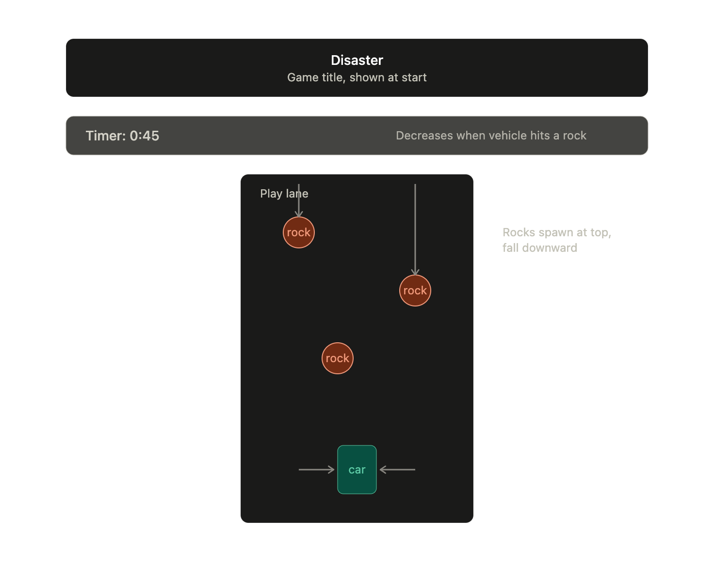

Project Concept Design

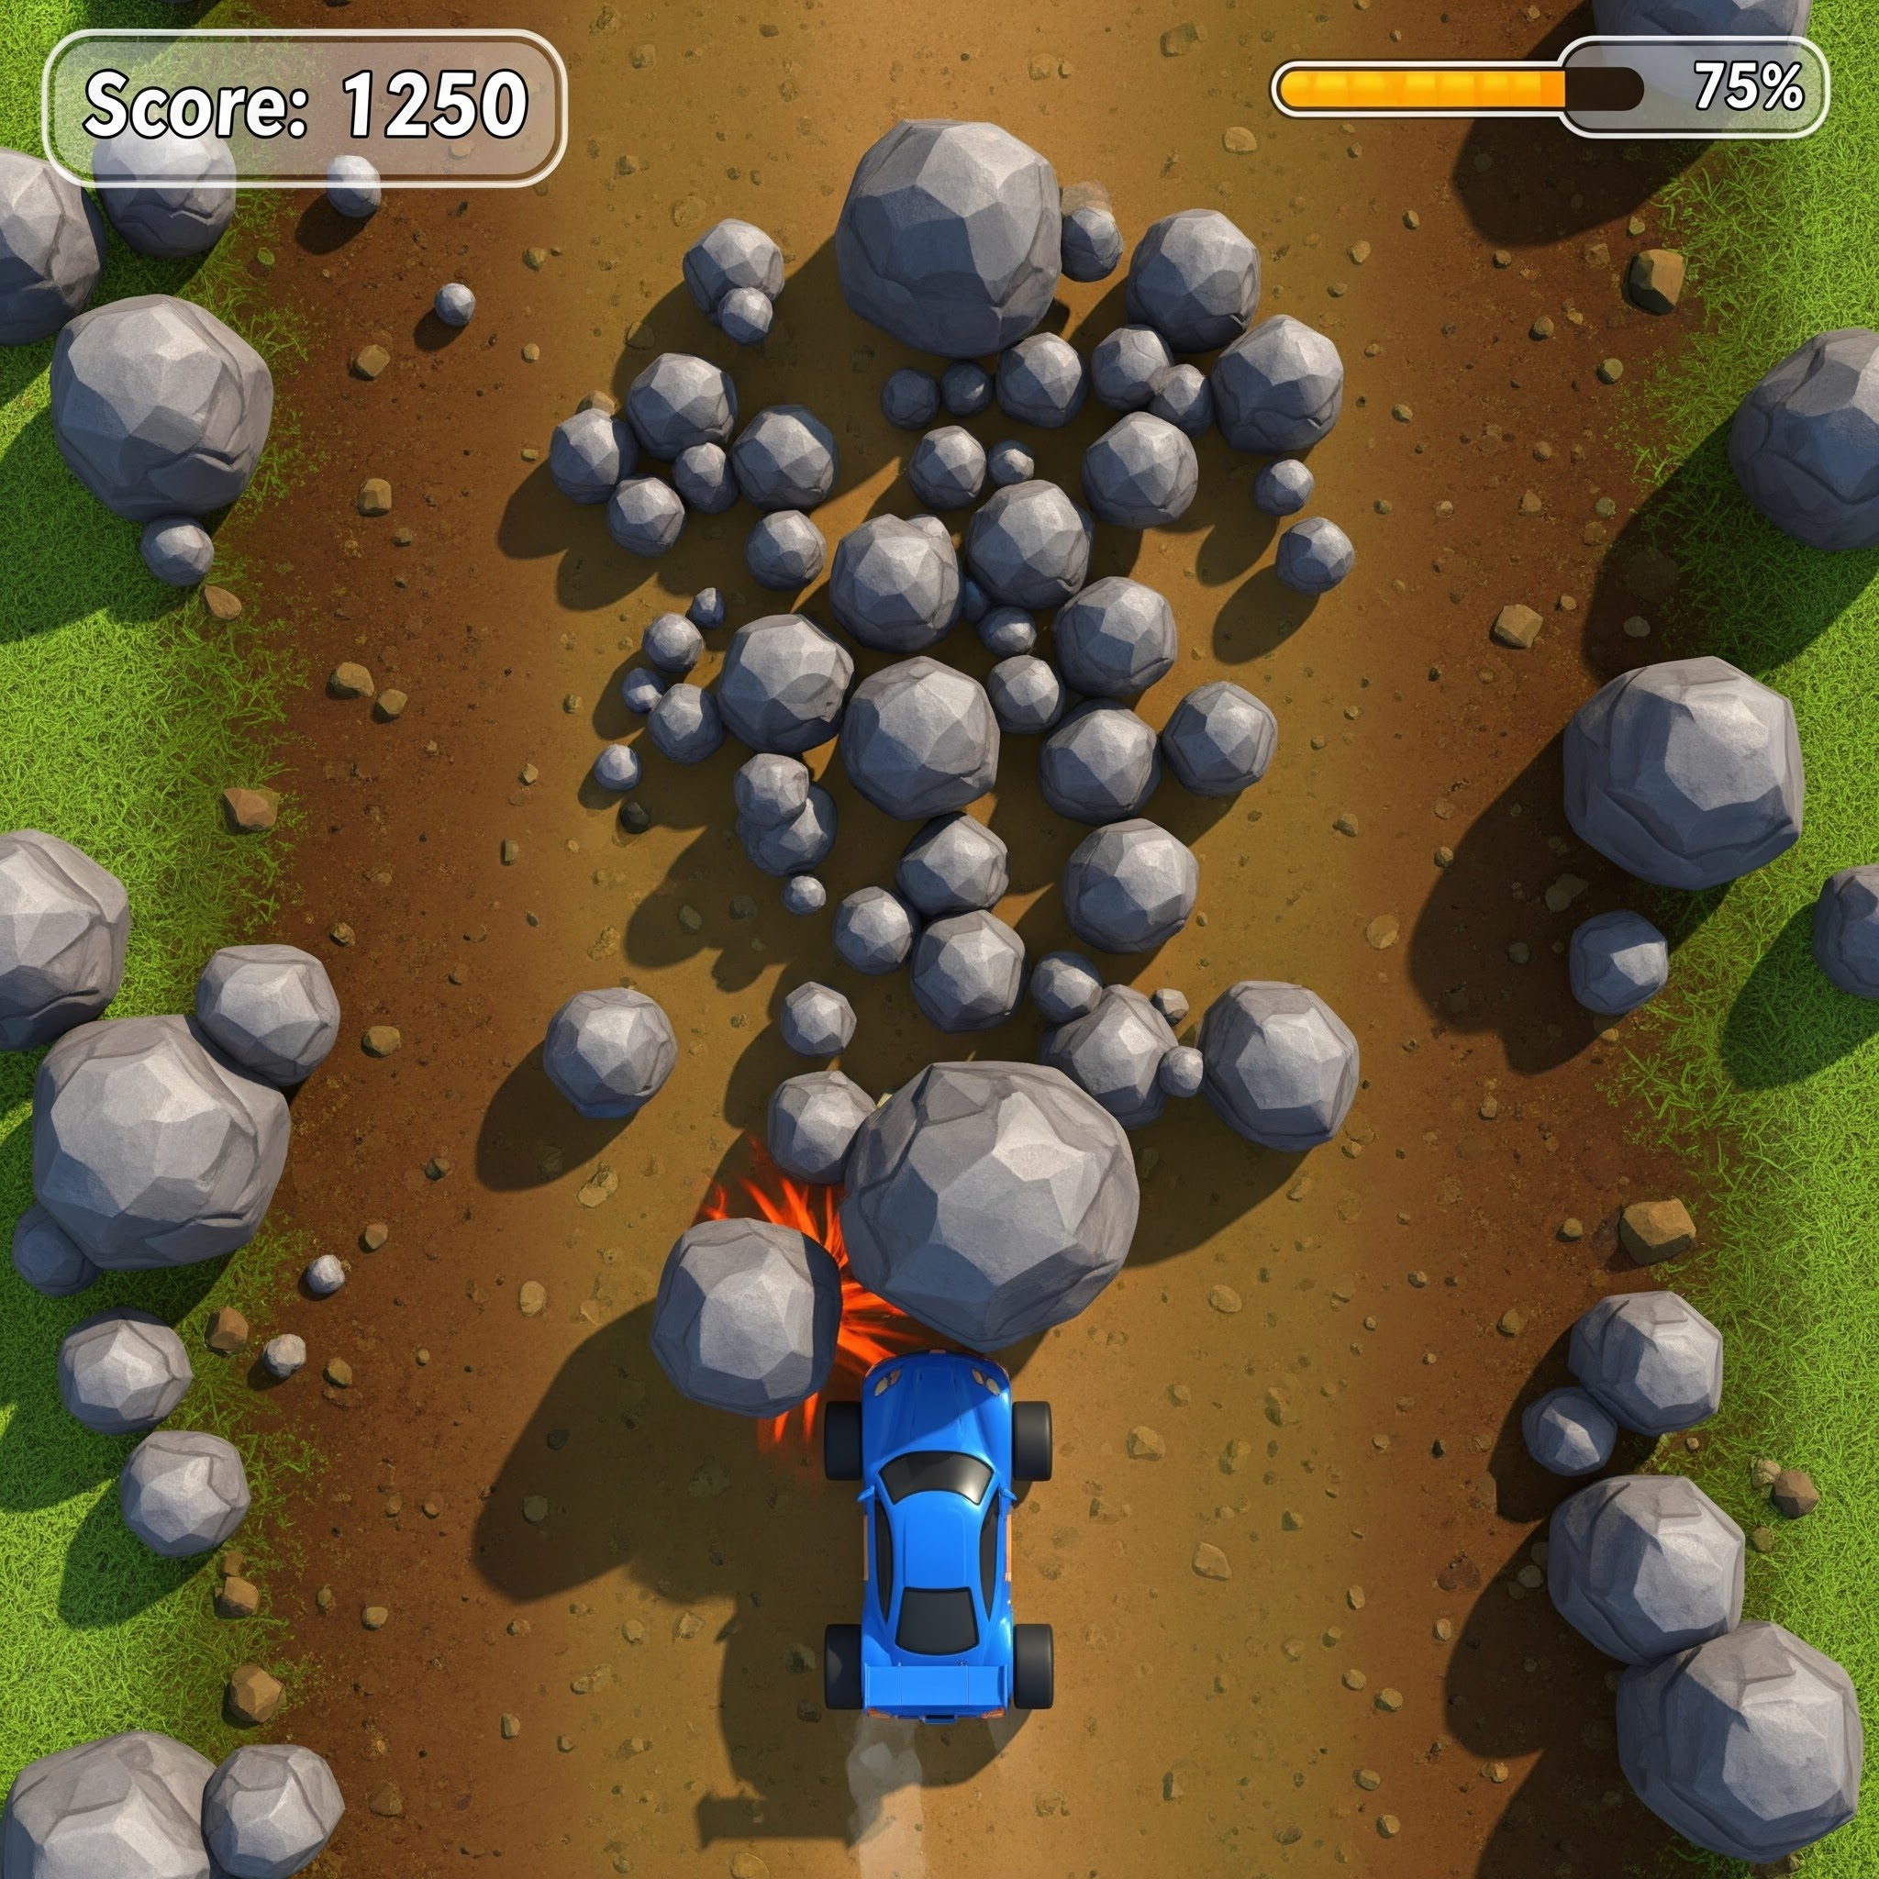 | 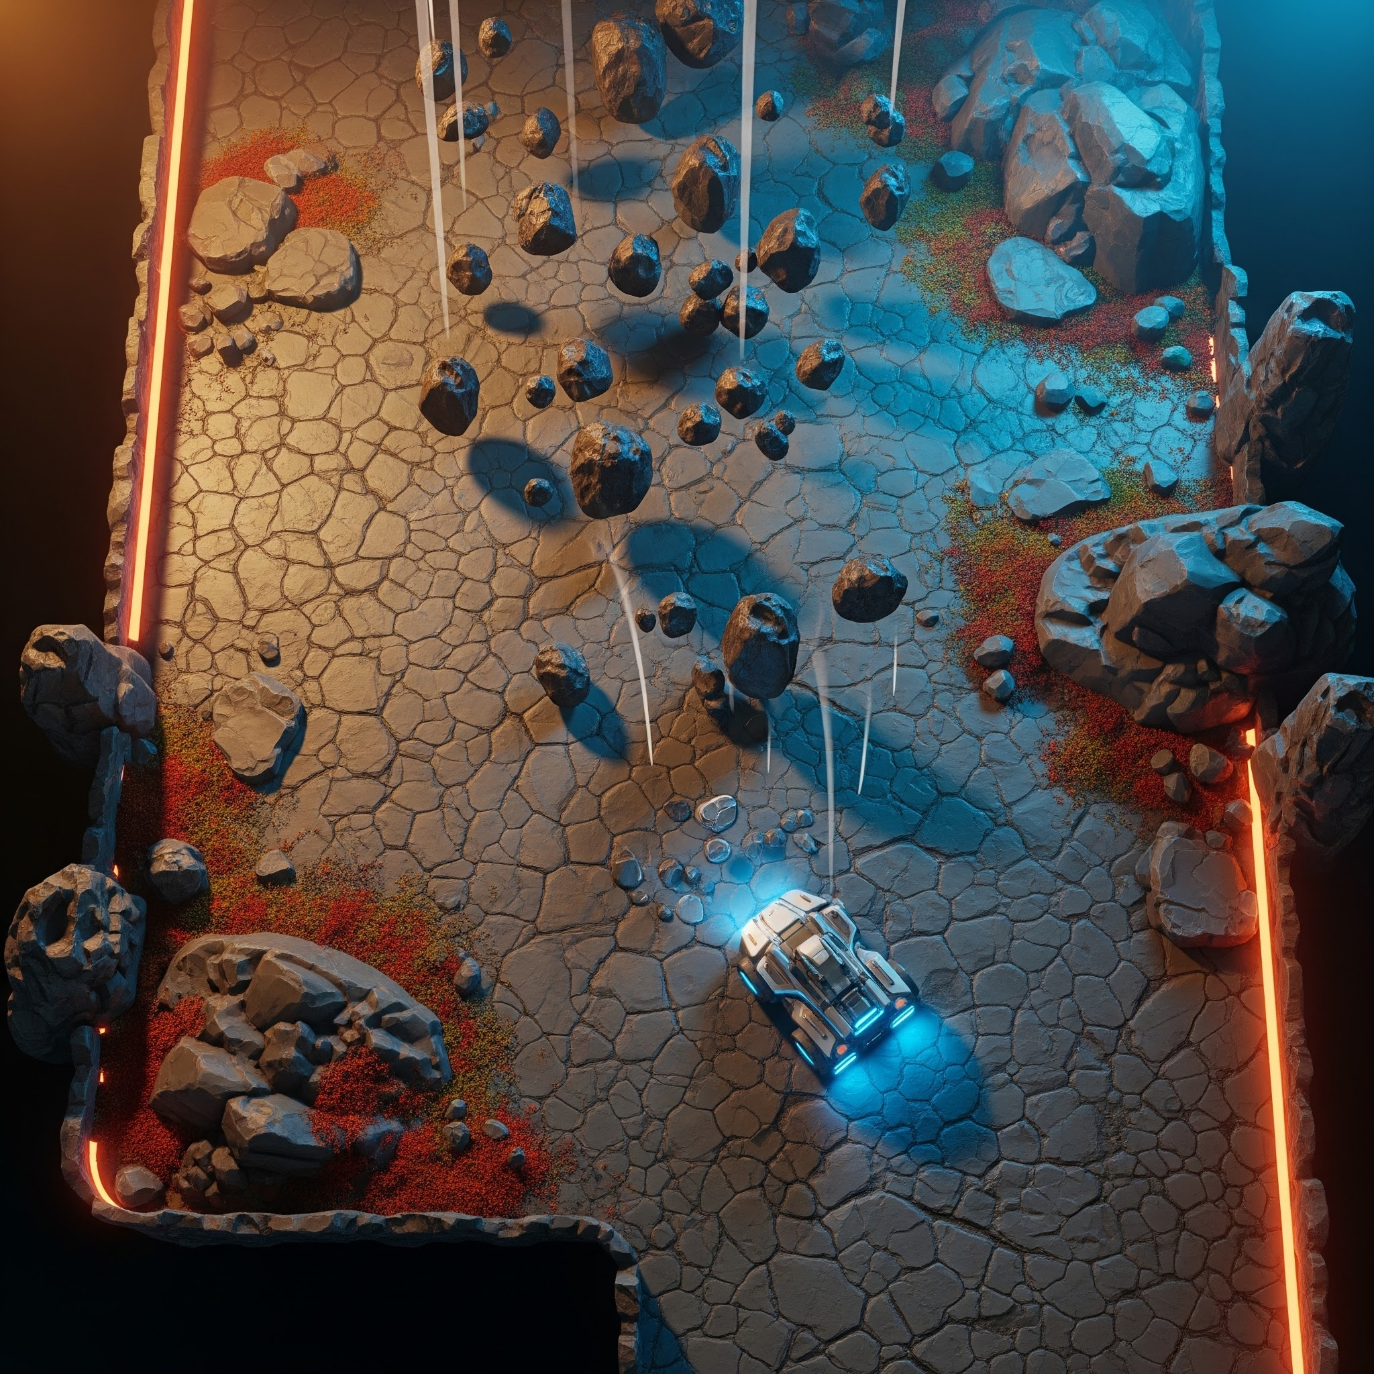
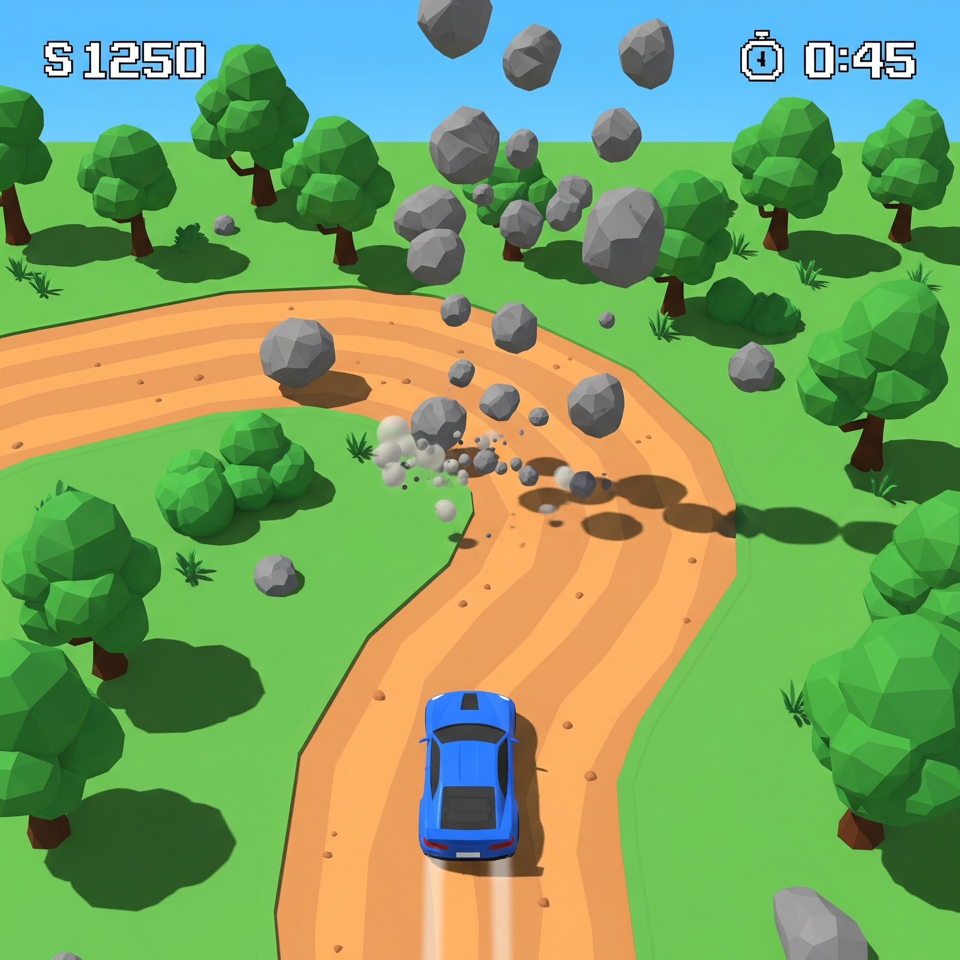 | 